**HSHSL Computer Cable Adapters Guide**

|  |  |  |
| --- | --- | --- |
| **Type** | **Description** | **Color** |
| Apple 30-pin male to VGA female (see page 2) | Connect **older iPhones and iPads** with a 30-pin connection to a monitor/projector with a VGA connection |  |
| Apple Lightning Digital AV male to HDMI female, plus Lightning female (see page 2) | Connect **newer iPhones and iPads** with a Lightning connection to a monitor/projector with a HDMI connection |  |
| Apple MiniDisplay male to HDMI female (see page 3) | Connect **Apple laptops with a MiniDisplay** connection to a monitor/projector with a HDMI connection |  |
| HDMI male to HDMI male extension cord (see page 3) | Reach a **long distance** between a computer and monitor/projector with **HDMI connections** |  |
| HDMI male to VGA female, plus Micro USB male to USB male (see page 4) | Connect **laptops with a HDMI** connection to a **monitor/projector with a VGA** connection |  |
| Micro HDMI male to HDMI female (2 inches) (see page 4) | Connect **Android phones and tablets** with a Micro HDMI connection to a monitor/projector with a HDMI connection |  |
| Micro HDMI male to HDMI female (six inches) (see page 5) | Connect **Android phones and tablets** with a Micro HDMI connection to a monitor/projector with a HDMI connection |  |
| VGA male to HDMI female, plus 1/8 inch audio jack, plus Micro USB male to USB male (see page 5) | Connect **laptops with a VGA** connection to a **monitor/projector with a HDMI** connection |  |

**Apple 30-pin male to VGA female**

Connect **older iPhones and iPads** with a 30-pin connection to a monitor/projector with a VGA connection

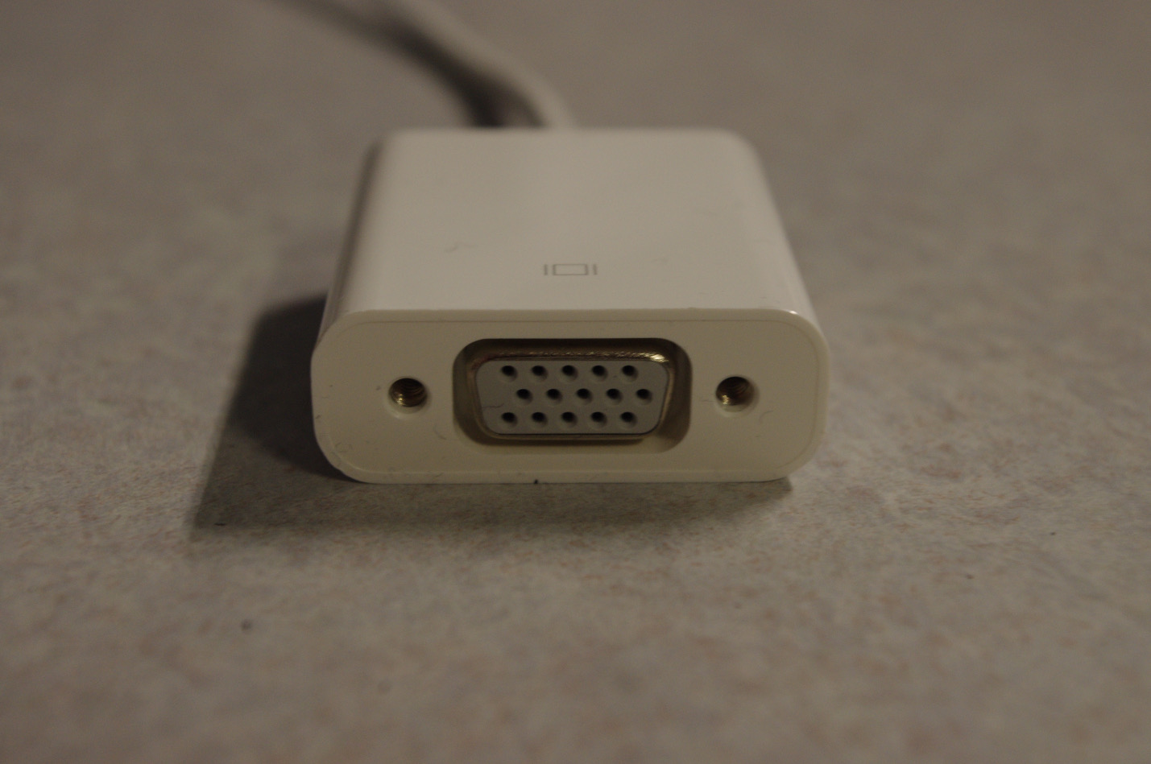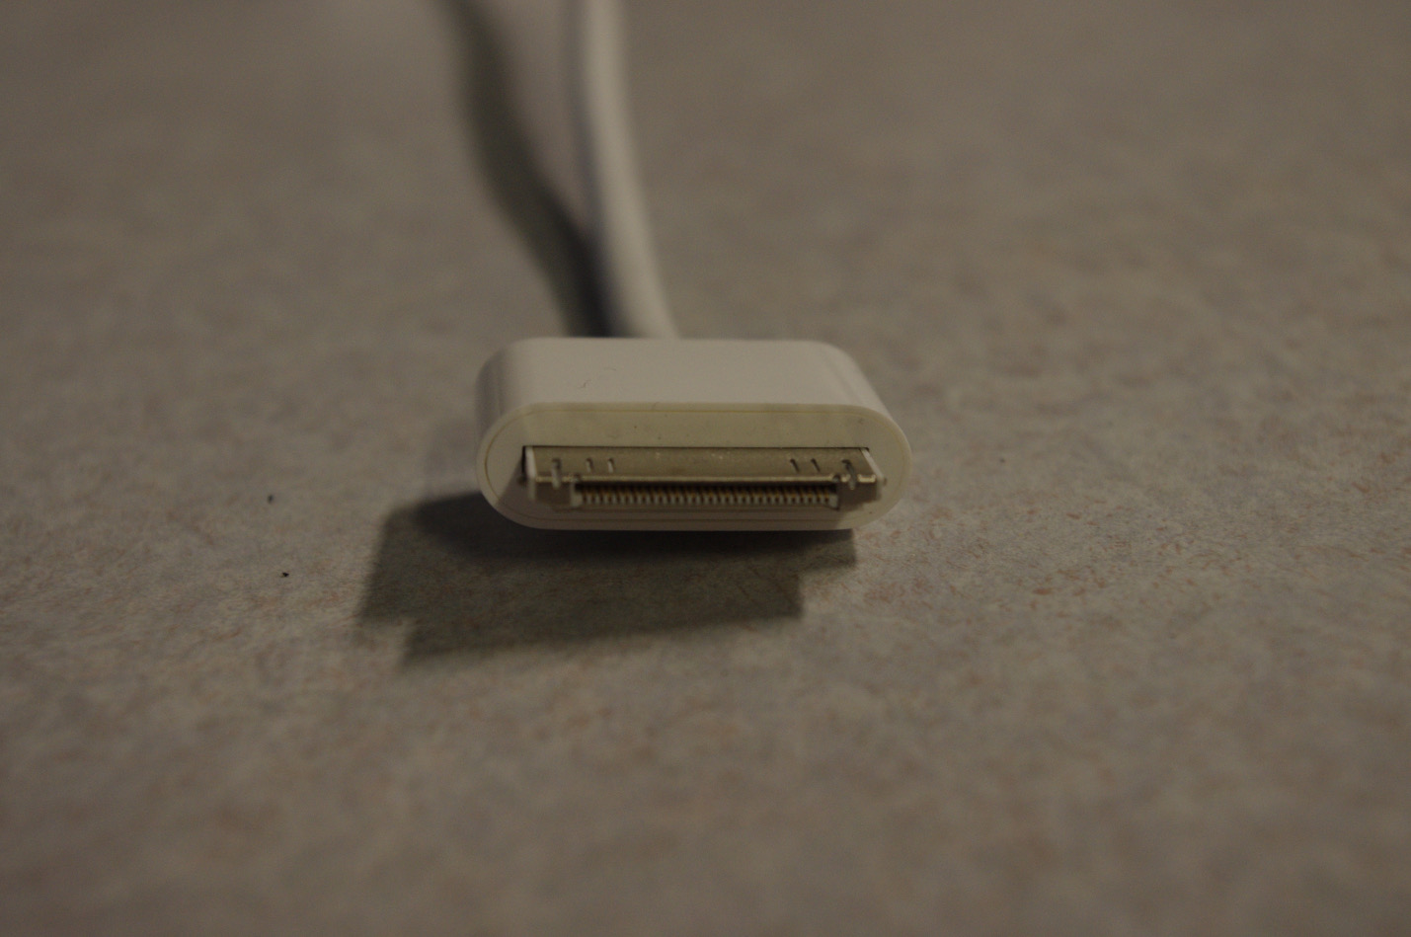

**Apple Lightning Digital AV male to HDMI female, plus Lightning female**

Connect **newer iPhones and iPads** with a Lightning connection to a monitor/projector with a HDMI connection

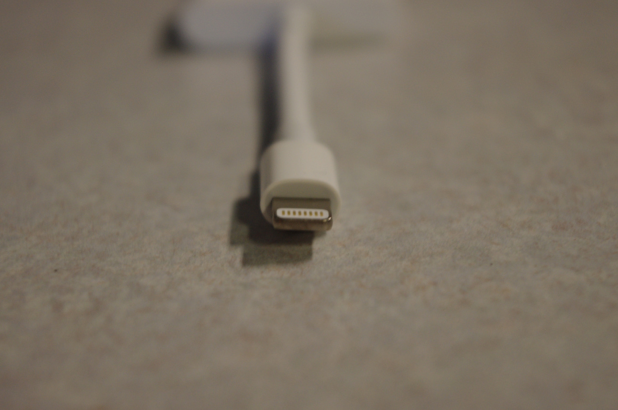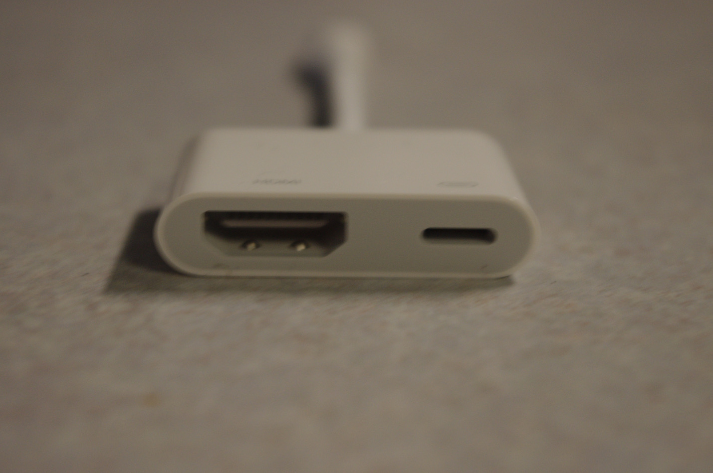

**Apple MiniDisplay male to HDMI female**

Connect **Apple laptops with a MiniDisplay** connection to a monitor/projector with a HDMI connection

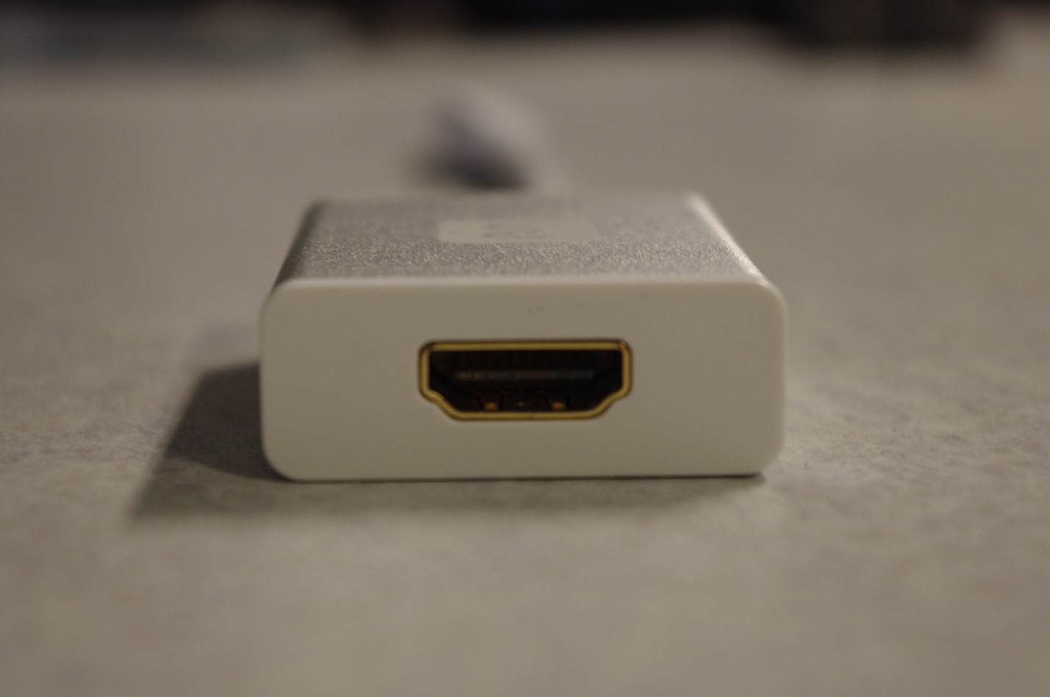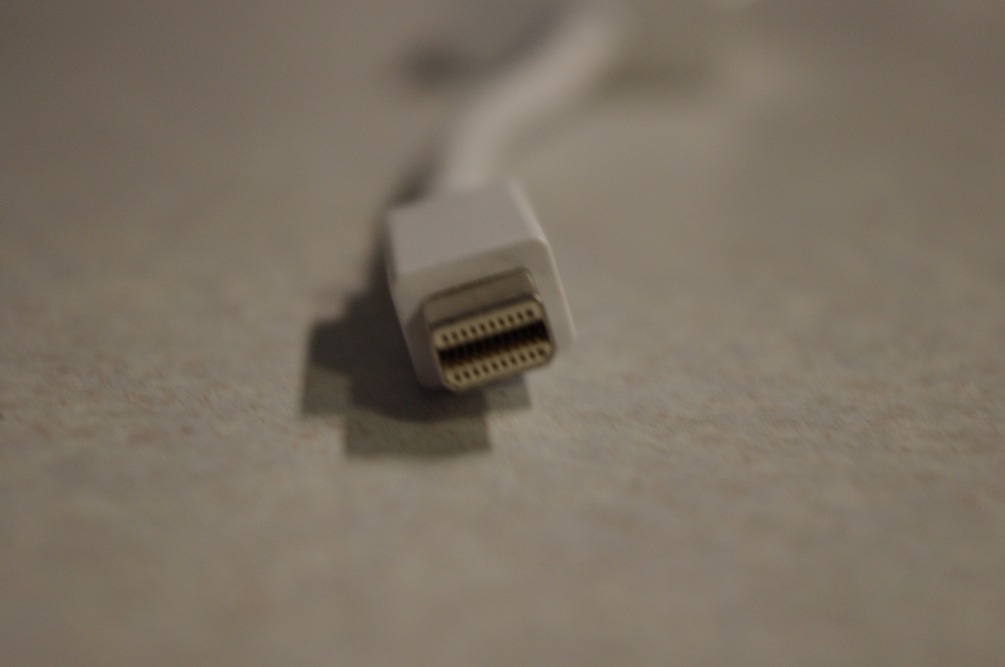

**HDMI male to HDMI male extension cord**

Reach a **long distance** between a computer and monitor/projector with **HDMI connections**

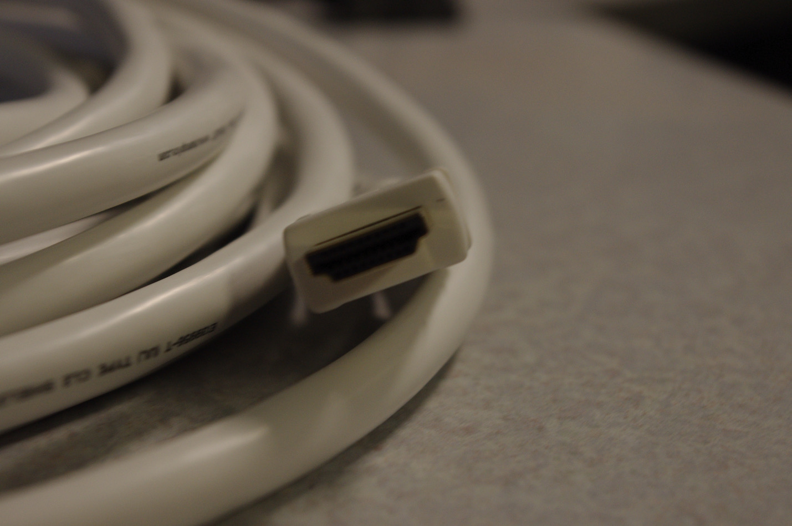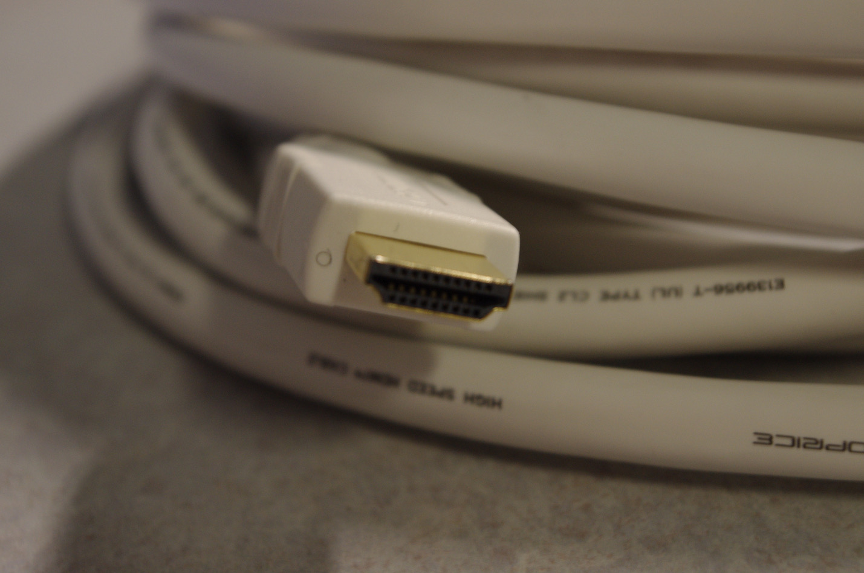

**HDMI male to VGA female, plus Micro USB male to USB male**

Connect **laptops with a HDMI** connection to a **monitor/projector with a VGA** connection

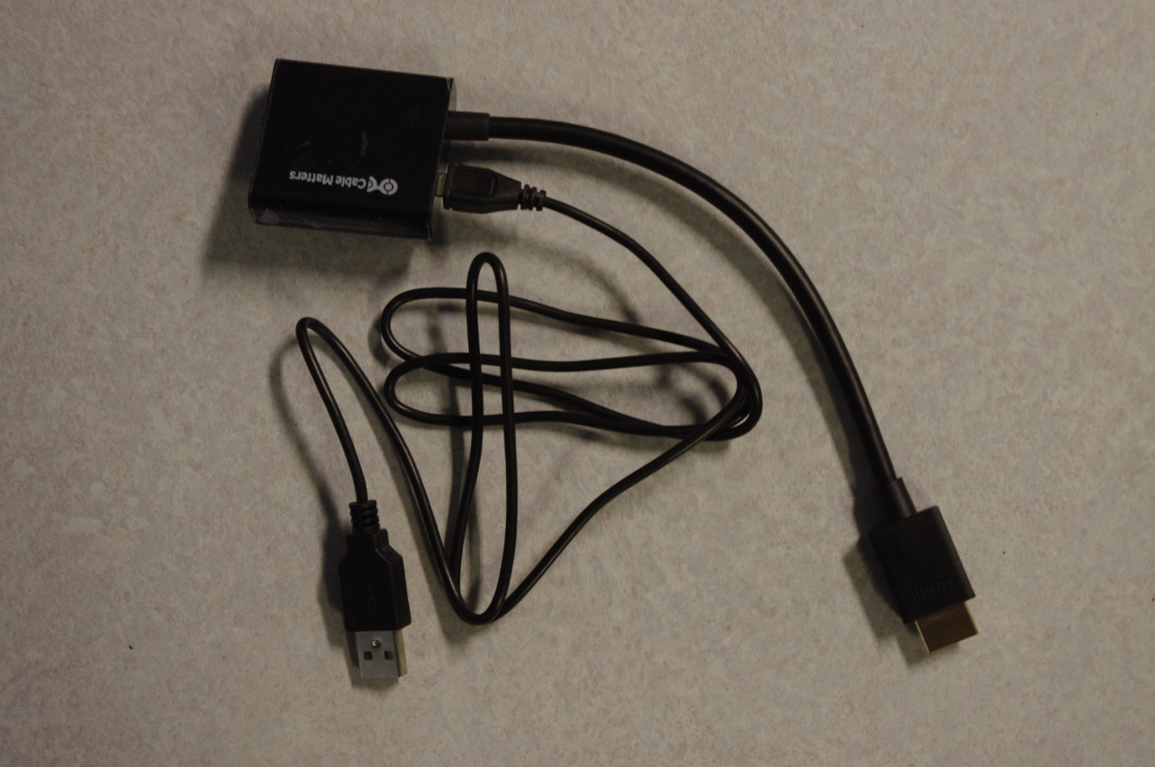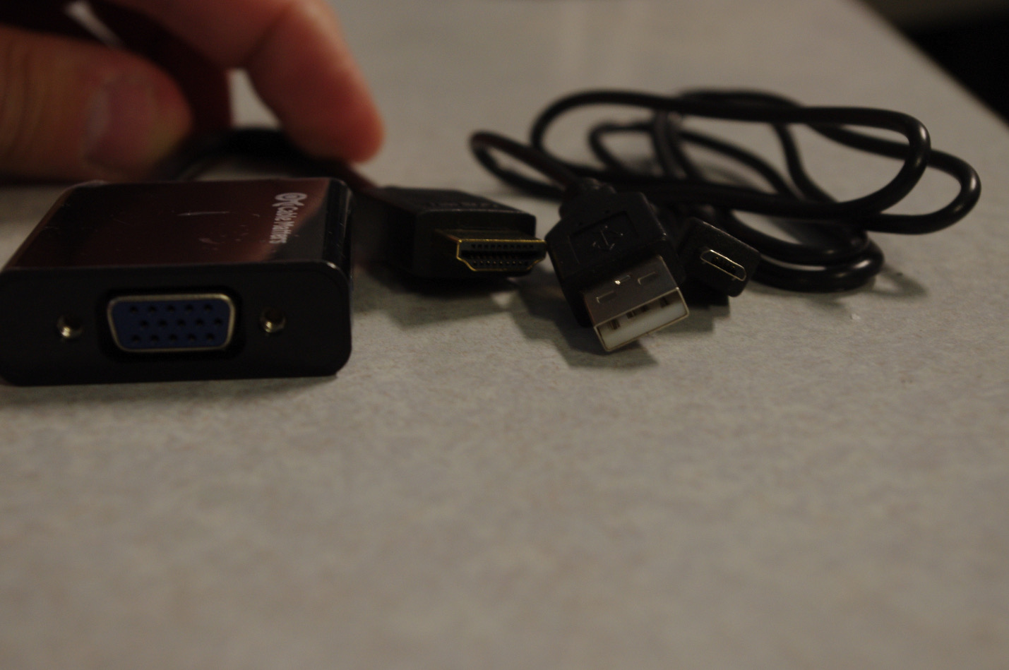

**Micro HDMI male to HDMI female (2 inches)**

Connect **Android phones and tablets** with a Micro HDMI connection to a monitor/projector with a HDMI connection

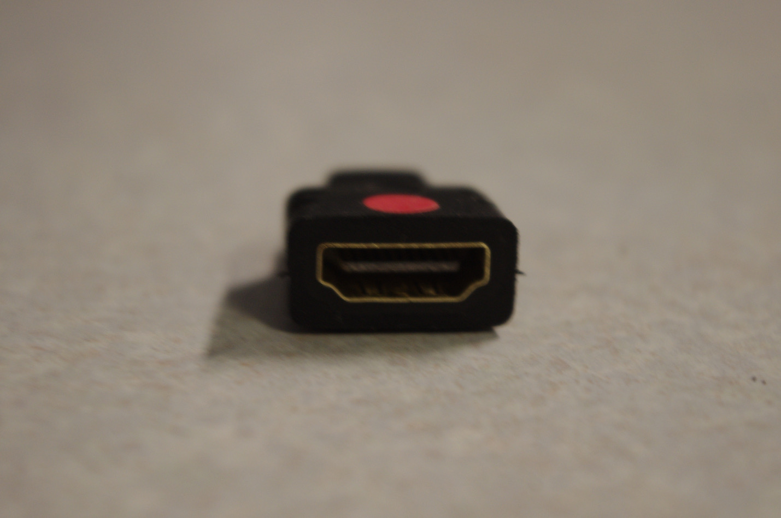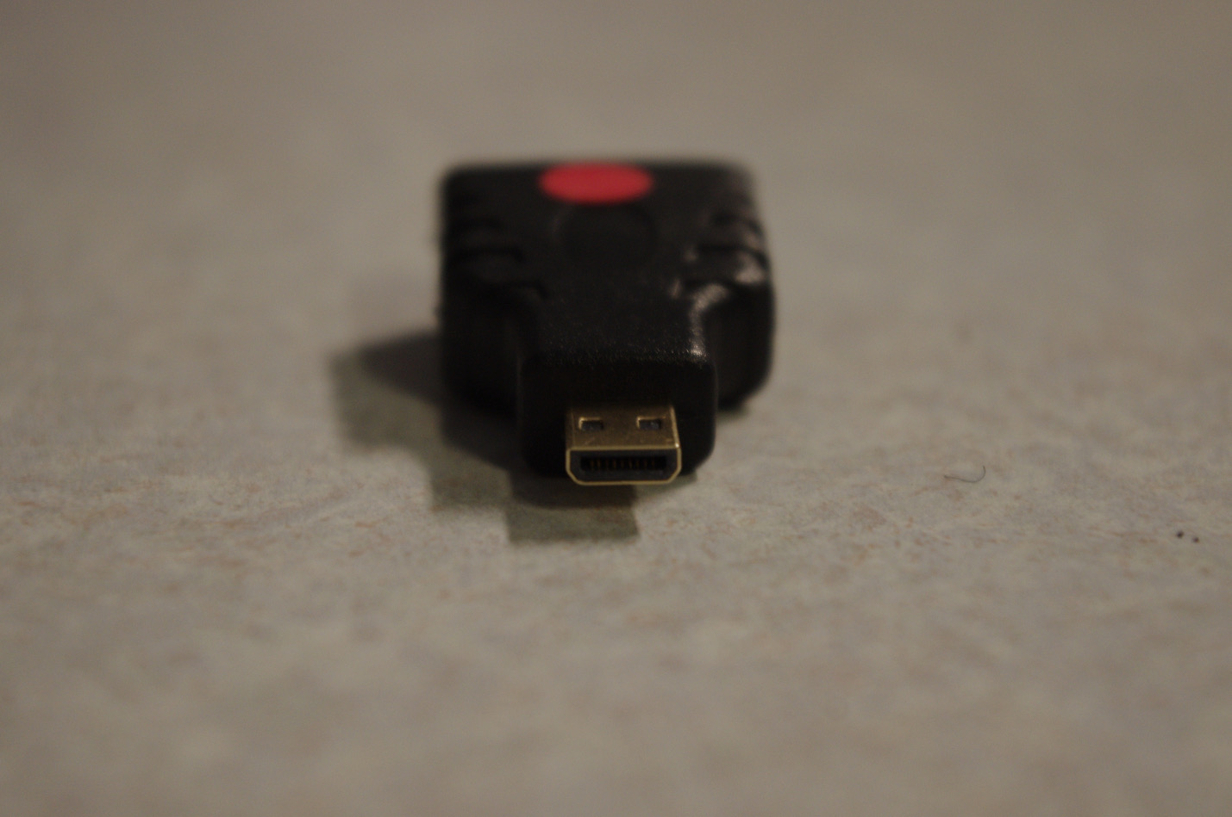

**Micro HDMI male to HDMI female (six inches)**

Connect **Android phones and tablets** with a Micro HDMI connection to a monitor/projector with a HDMI connection

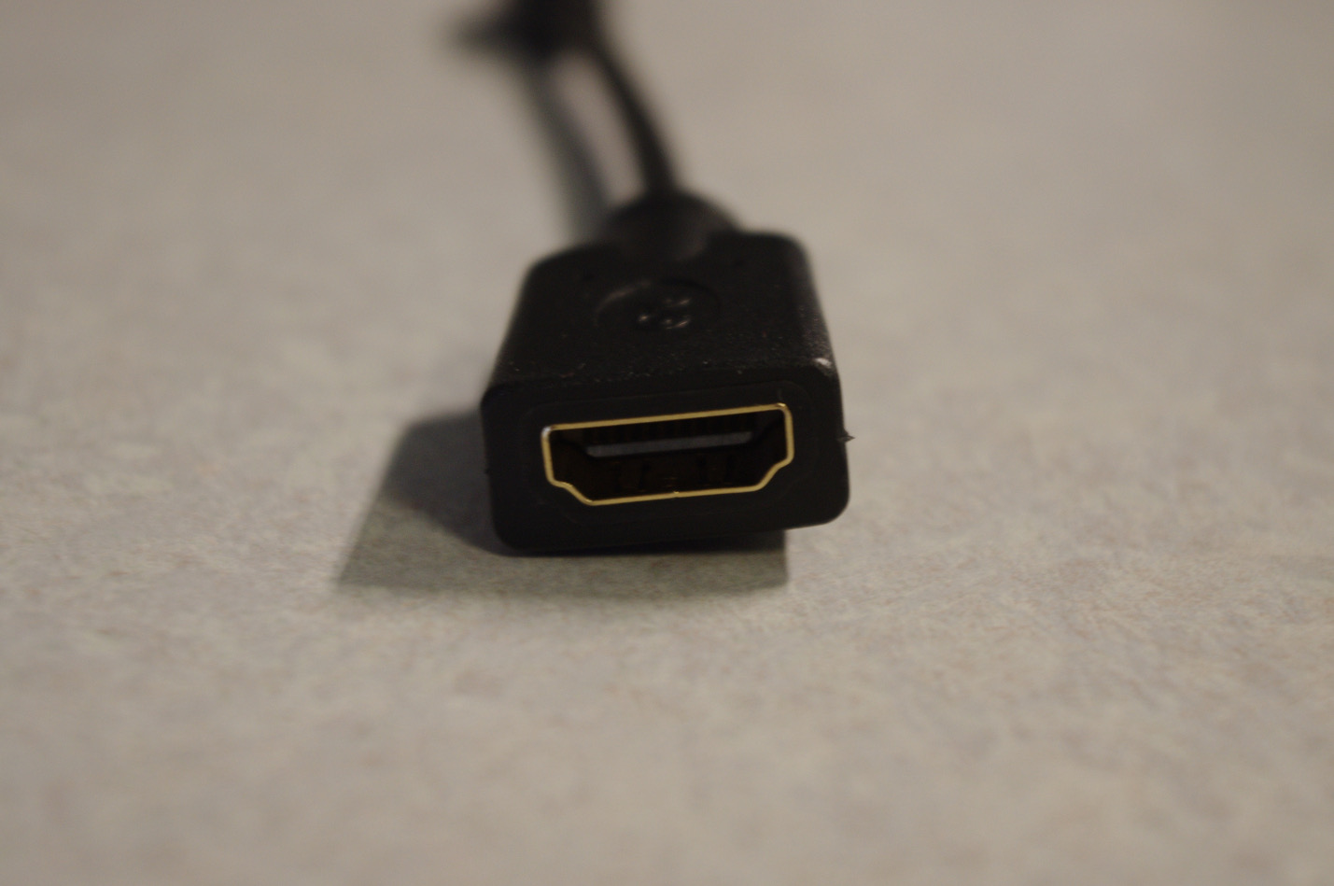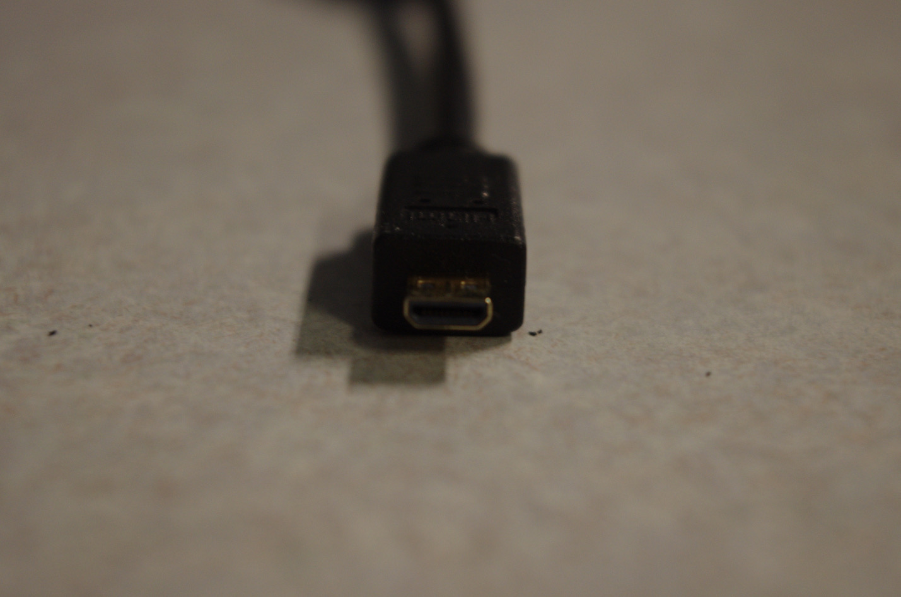

**VGA male to HDMI female, plus 1/8 inch audio jack, plus Micro USB male to USB male**

Connect **laptops with a VGA** connection to a **monitor/projector with a HDMI** connection

